Preliminary Study for   
Robot-Assisted Endodontic Treatment

Chia-Jou Kuo  
*Department of Electrical Engineering*  
*National Taiwan Univercity*Taipei, Taiwan  
b05901166@ntu.edu.tw  
  
Yi-Chan Li  
*Department of Electrical Engineering*  
*National Taiwan Univercity*Taipei, Taiwan  
r08921079@ntu.edu.tw  
  
Cheng-Wei Chen  
*Department of Electrical Engineering*  
*National Taiwan Univercity*Taipei, Taiwan  
cwchenee@ntu.edu.tw

*Abstract*—This paper introduces a method that reduces the possibility of instruments fracture during the endodontic therapy. When instruments fracture happens, the retained broken files would obstruct the filling of root canal. In order to reduce the occurrence of instruments fracture, we propose a method using motor current feedback to keep track of the torque which the file is bearing. In this way, the torque can be limited during the whole endodontic procedure. A prototype of an automatic endodontic robot with the proposed current feedback method is implemented. In addition to reducing the occurrence of instrument fracture, the robot also facilitates the repetitive procedure during the root canal treatment by automatically performing the repetitive drilling.

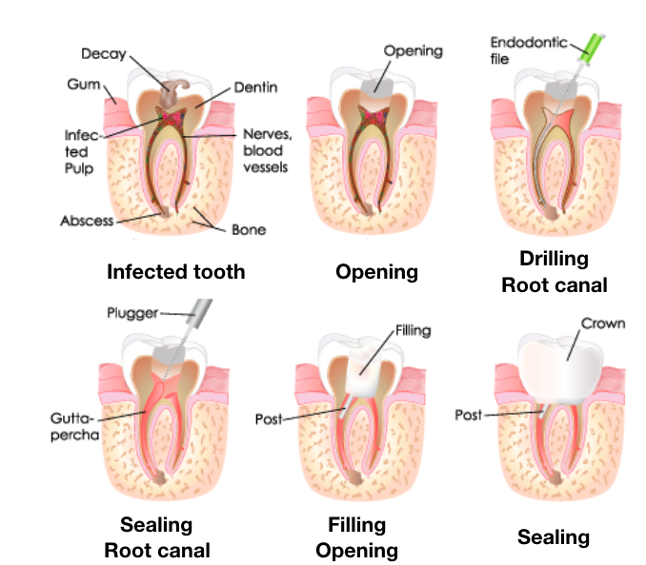

Fig. 1. The endodontic therapy steps [4].

Keywords—torque detection, current feedback, endodontic treatment, root canal treatment, dental robot

# Introduction

Endodontic therapy, also known as root canal treatment, is performed to prevent a tooth from being infected. According to American association of endodontists, more than 15 million root canal treatments are performed every year [1] . Although this therapy had been so prevalent, the outcome largely depends on the clinician’s experience and expertise. Instruments fracture and perforation are two problems that commonly occur during the therapy. Removal of broken files is both technically difficult and therefore it is important to reduce the probability of fracture [2] . In addition to these problems, root canal treatment also requires repeatedly drilling in order to clean the canal thoroughly (Fig. 1, “Drilling Root Canal” step). This repetitive action of root canal treatment is tedious and time-consuming. Therefore, we designed an automatic endodontic robot to improve the time-efficiency and to reduce the occurrence of instrument fracture in endodontic surgery.

There is one robotic system that is designed to perform endodontic therapy. In Intelligent Micro Robot Development for Minimum Invasive Endodontic Treatment [3] , they proposed a micro robot performing root canal treatment with the assistance of 3D computer model system. It is designed to accomplish endodontic therapy with path planned according to the 3D model. However, the problem of instruments fracture still remains.

In this paper, a torque monitoring method is proposed. The main causes of fractured files are torsional fracture and flexural fatigue, account for 55.7% and 44.3% separately [5]. Therefore, we use current feedback to keep track of the torque which the file is bearing during the endodontic treatment. This torque monitoring system is implemented on an endodontic robot prototype we built. We primarily focus on the cleaning and shaping step since it’s the key step to a successful root canal treatment. With the robot prototype and torque monitoring system, the possibility of instrument fracture can be reduced. Besides, the repetitive action during the drilling step can be performed by the robot.

The main contribution of this work is the method to measure current or voltage to monitor the torque of the file. This method can be used to increase the performance of endodontic surgery by preventing file torsional overload. The remainder of this paper is organized as follows: the torque monitoring methods using current feedback and velocity control is given in Section 2. The mechanism design and experiment procedure are described in section 3. Section 4 demonstrates the prototype of our endodontic robot and the result of our experiment. Section 5 provides the conclusion.

# Methods To Monitor Applied Torque

Instruments fracture occurs when the endodontic file is bearing torque that exceed the limitation. The maximum torque a root canal file can bear is 6.20Ncm [11]. The easiest and most effective way to solve this issue would be monitoring the torque which the file is enduring. Therefore, we proposed two methods to keep track of the torque during robot-assisted root canal treatment.

## Torque Sensing from Current Feedback

A motor can be modeled as an RL circuit. In this way, we can get the following formula where *V* represents the input voltage, *I* represents the input current, and *ɛ* represents the back EMF produced by the motor motion.

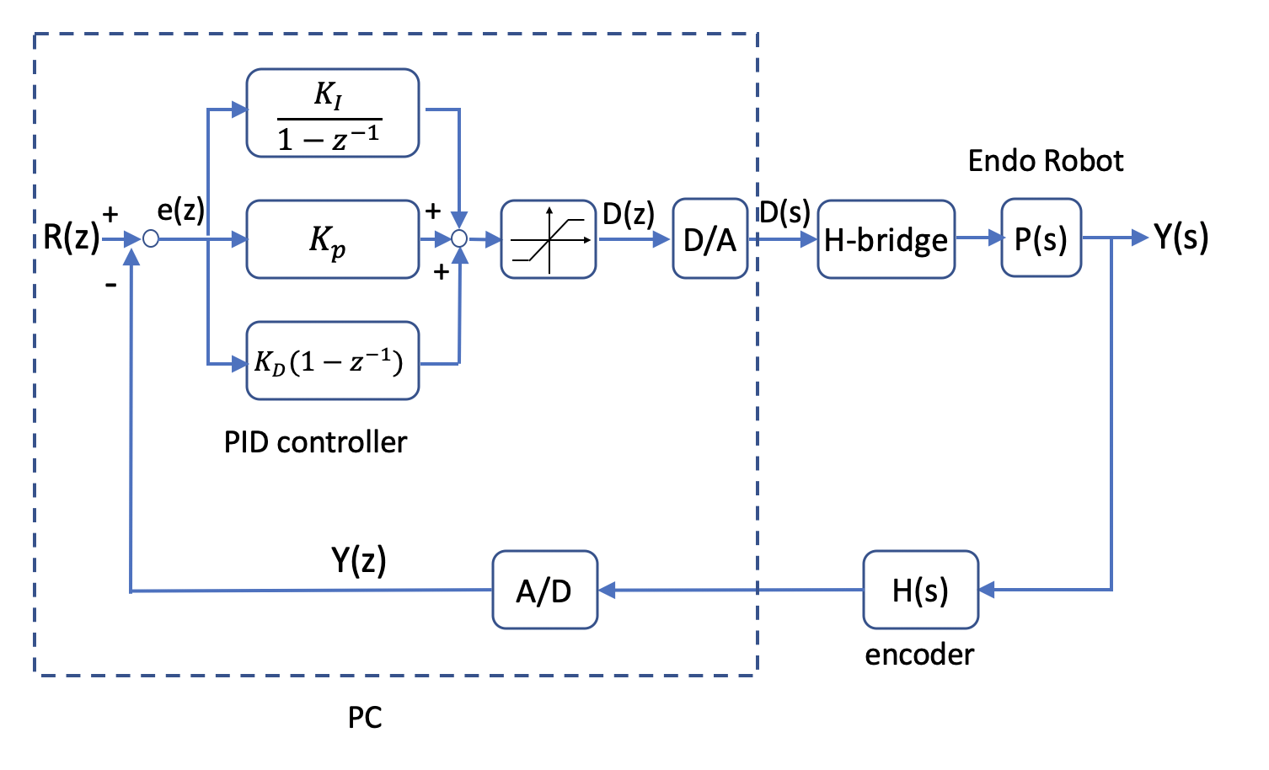

Fig. 3. Velocity control block diagram. R(z) represents the referenced velocity and D(s) represents the duty cycle. H-bridge controls the rotation direction of the file depends on whether the duty cycle exceeds the voltage theshold.

$V = R * I + L*\frac{dI}{dt}+ɛ$



Since the value of inductance of DC motor is small, we ignore the inductance term *L*. After transposition, we can get the following relation between current and the back EMF.

$I=\frac{V-ɛ}{R}$



The back EMF produced by the motor is dependent upon the motor constant *K*, shown as the following equation.

$ɛ= K \frac{dθ(t)}{dt}=K*ω(t)$



When the file encounters resistance during the drilling procedure, the rotating speed of the motor would slow down. With (2) and (3) we can infer that the back EMF would decrease, and the current would increase.

With the ability to detect the current, which represents the torque which our endodontic file is enduring, we can prevent instruments fracture, as the block diagram shown in Fig. 2. When the file encounters a torque that exceeds the threshold, the file would rotate 90 degrees in the counter direction. After that, it continues the original rotation until the file reaches the root canal tip.

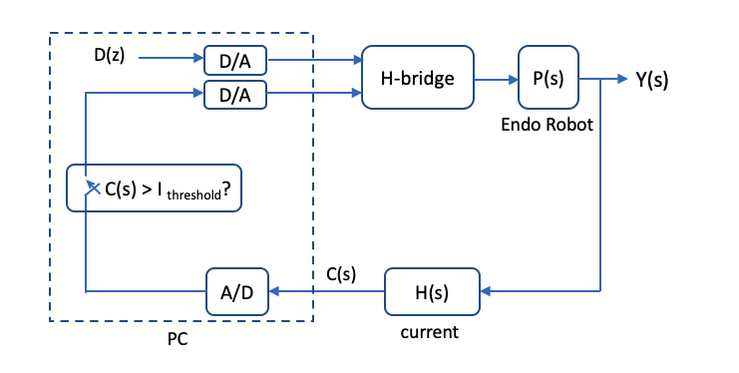

Fig. 2. Current feedback block diagram. D(z) represents the duty cycle, C(s) represents the current feedback and Y(s) represents the position. H-bridge controls the rotation speed according to D(z) and invert the rotation direction when current feedback exceeds the threshold.

## Velocity Control with Torque Estimation

Besides using current feedback to monitor the torque, we propose another method using velocity control accompany with voltage monitor to achieve the same goal (Fig. 3). With the encoder equipped on the servo motor controlling the endodontic file, we can implement voltage control on the drilling velocity. Since the rotating velocity of the file would slow down when the file encounters more resistance, the voltage should therefore be increased. With velocity control, we can measure the voltage provided for the motor to monitor the torque which the file is bearing. In order to prevent instrument fracture, we can use the voltage information just like current feedback in the previous section to perform the endodontic treatment.

# Prototype design

In this section, a prototypical robot for root canal treatment is proposed. The preliminary procedure defined for robot-assisted root canal treatment is implemented on this porotype.

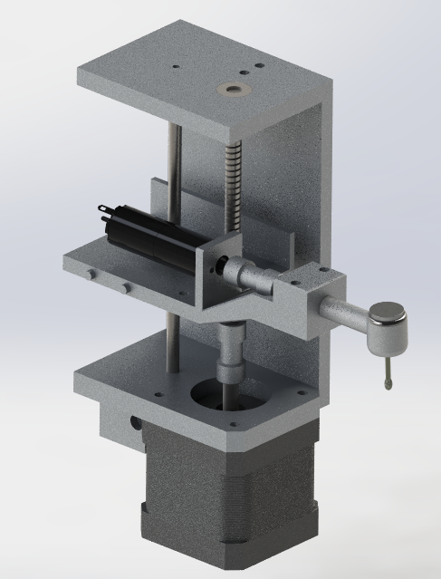

Fig. 4. The automatic endodontic robot machanism design.

## Mechanism Design

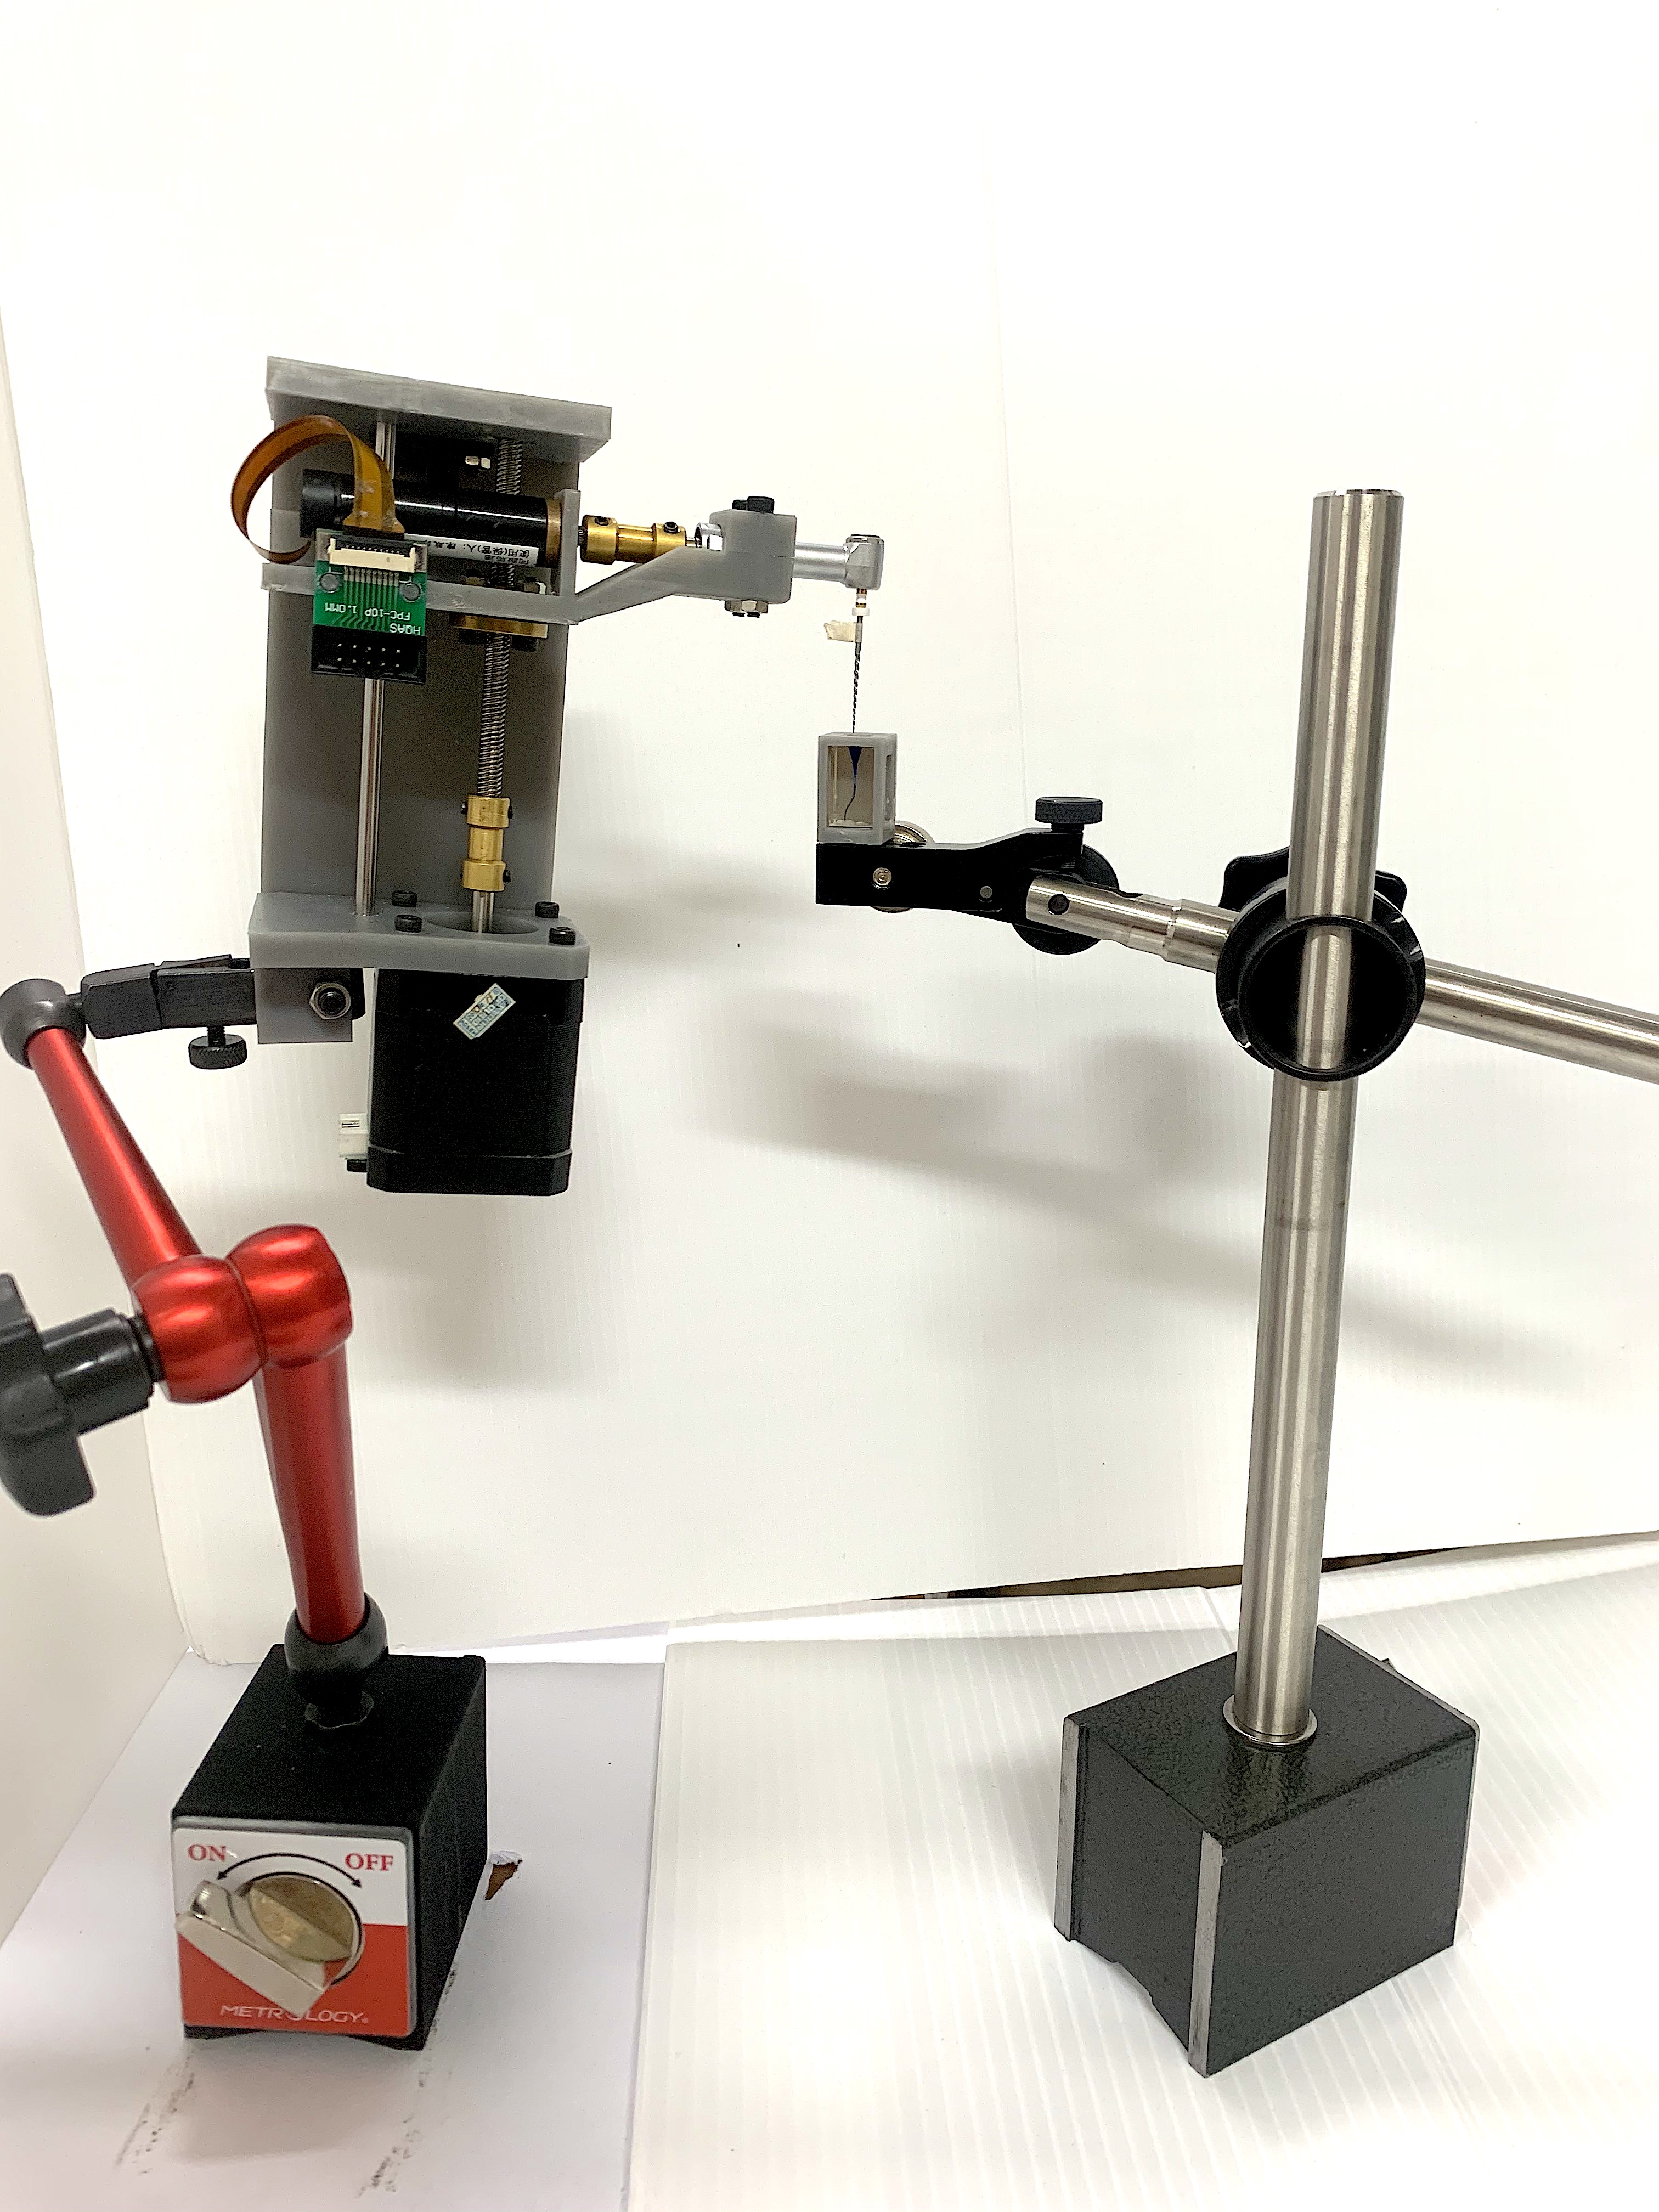

Fig. 6. The endodontic robot prototype.

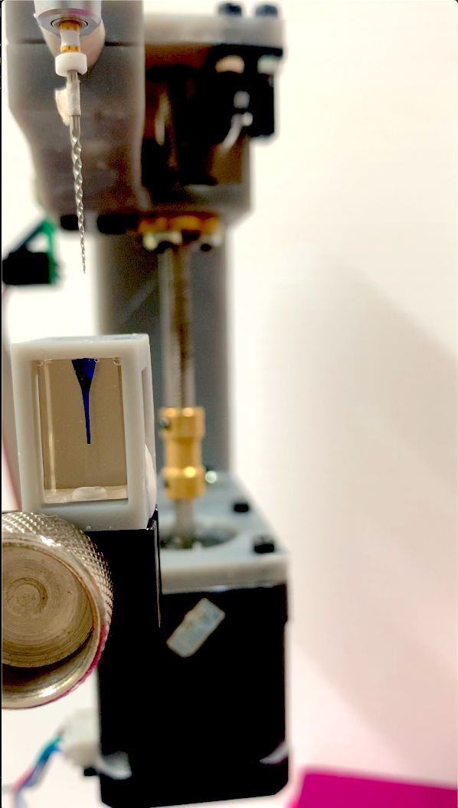 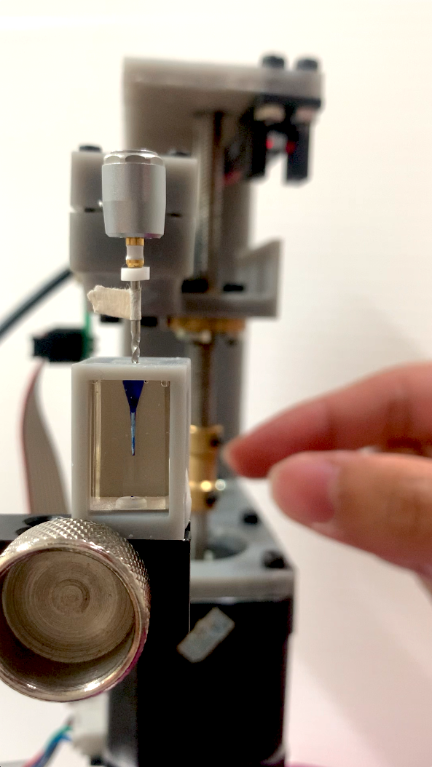

1. (b)

Fig. 7. Drilling procedure. (a) Starting the drilling. (b) During the drilling.

In order to accomplish the repetitive action during root canal treatment, we designed a drilling system mounted on a magnetic stand shown as Fig. 4. The file on this robot is driven by a servo motor with rotation speed up to 700 rpm. As for the current feedback, we used a motor driver board equipped with a current feedback pin. When the file is bearing resistance that exceed a specific threshold, the file will rotate in the reversed direction for 90 degrees and then continue drilling in the original direction [6] . The steps of our experiment is shown as Fig. 5.

## Procedure for Robot-Assisted Endodontic Therapy

With our endodontic robot design, the system will perform the following step to accomplish root canal treatment (Fig. 5).

### Homing. The stepper motor reset the position of the file.

### Move to start position. This preparation step requires human operation to adjust the magnetic stand in order to move the file tip to the starting point.

### Drilling. The root canal is devided into several section. Our robot will repetitively drill one section back and forth at least five times until the current feedback decrease under threashold. After one section is cleaned thoroughly, the drilling file will move to the next section.

### Reversed Drilling. When the file encounters resistance that exceeds the current feedback threshold, it rotates 90 degrees in the counter clockwise. After the counter directional rotation, the procedure goes back to step 3 until the file reaches the root canal tip.

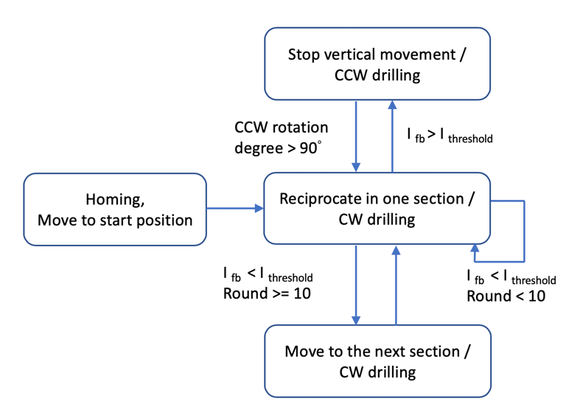

Fig. 5. The drilling procedure flow chart. (Ifb and Ithreashold represent current feadback and current threashold respectively. A/B in this figure represents the moving/drilling direction of the file.)

# Experimental Result

The proposed torque monitoring method with current feedback is implemented with an automatic endodontic robot as shown in Fig. 6. Automatic drilling experiment is conducted to evaluate the feasibility of using current feedback to prevent file breakage and perform the endodontic treatment automatically.

We used Acrylic root canal training block to conduct our experiment (Fig. 7). During the drilling procedure, the file rotates clockwise during both upward and downward drilling. In this way, we can ensure that the root canal is cleaned thoroughly once the current feedback decrease down to the current feedback threshold. As shown in Fig. 8, the colored root canal wall is cleaned after drilling by our endodontic robot prototype.

## Current feedback

B

Ａ

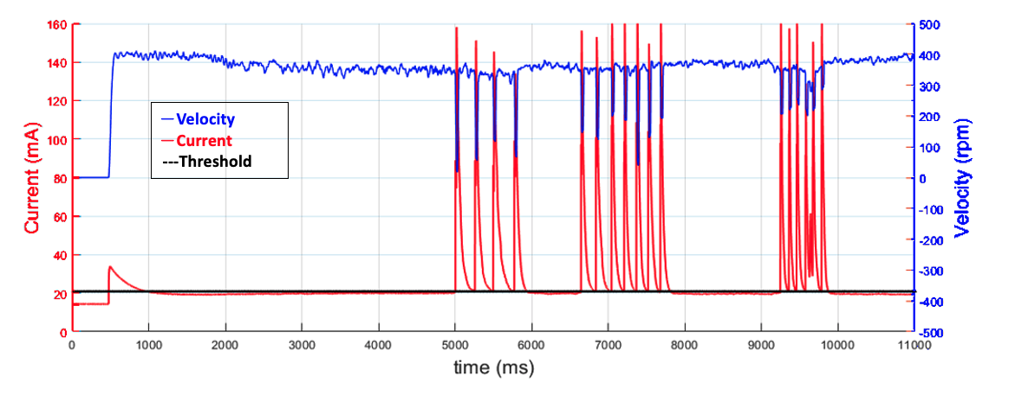

Fig. 10. The current feedback-time chart with three reversed rotation.

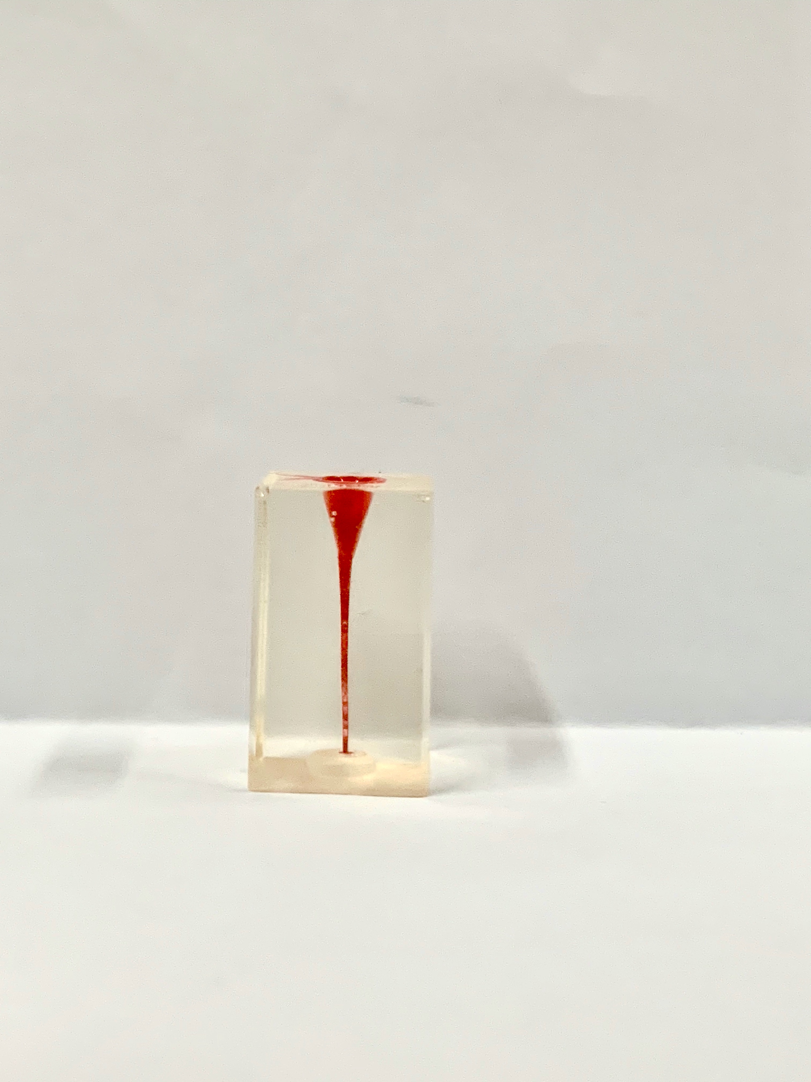 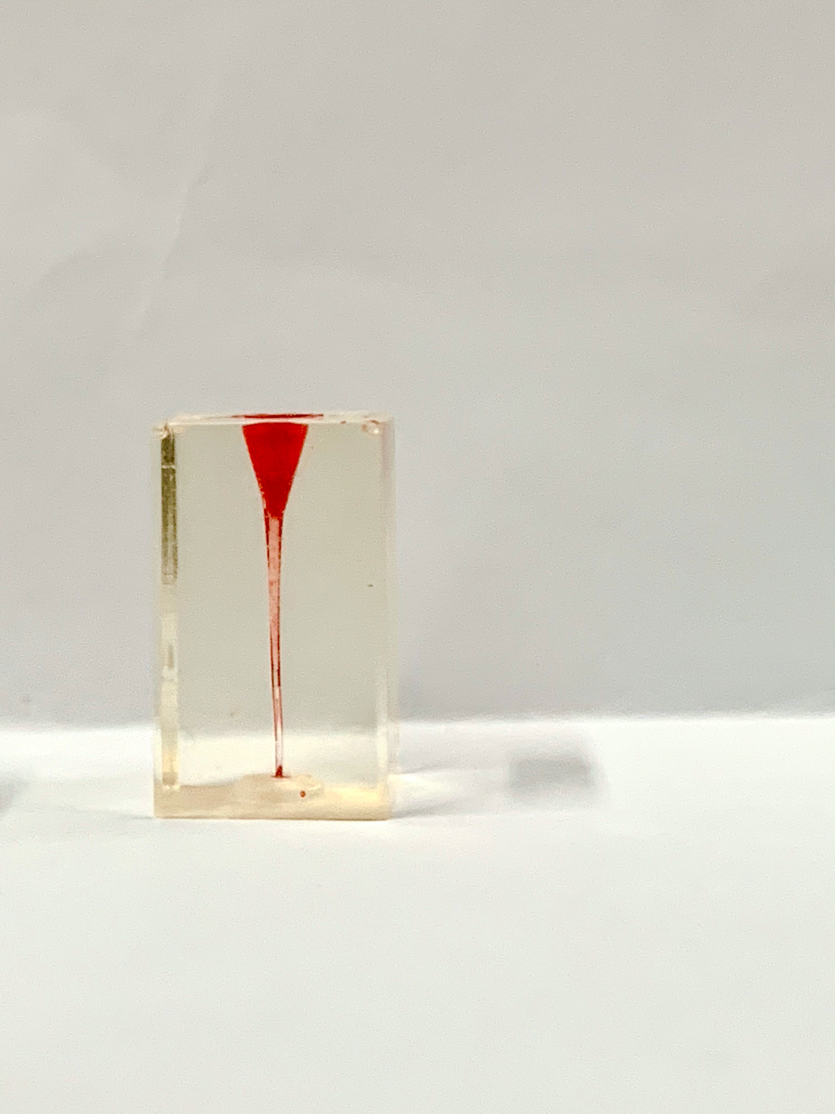

1. (b)

Fig. 8. Acrylic root canal (a) before and (b) after drilling.

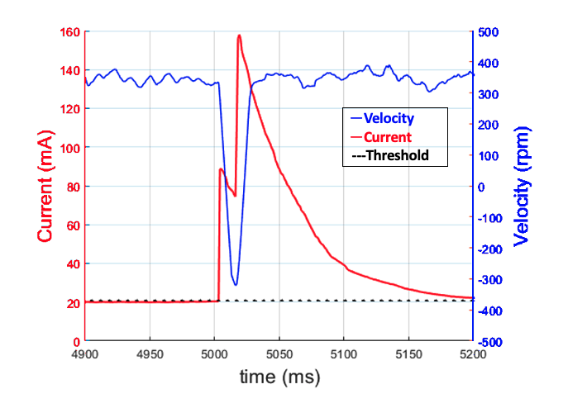

Fig. 9. The current feedback-time chart with single reversed rotation.

As we can see in Fig. 9, there are two peaks (labeled as peak A and B) in the current feedback chart. When the drilling file encounters torque that exceeds threshold, the rotating direction reverses, the resistance would therefore decrease and the rotation speed increase. Since the rotation speed increase, the current feedback would decrease accordingly. At the moment which the file rotating speed is zero, the back EMF ɛ produced by the motor will become zero and the current feedback will reach the peak A in Fig. 9 according to (2) and (3). After 90 degrees of counterclockwise rotation, the rotating direction changes again and thus creates the second current feedback peak B in Fig. 9.

As shown in fig. 9, Peak B is higher than peak A because the endodontic file we are using in this experiment for shaping the root canal is K-file, which is designed to cut the root canal in clockwise rotation. Therefore, clockwise rotation will encounter greater resistance during the drilling procedure and the current feedback is thus greater than counterclockwise rotation.

## Reversed drilling

In Fig. 10, there are 3 clusters of single reversed rotation peaks. One cluster indicates drilling through one section. Since the existence of a peak means that the root canal is not shaped properly, our system will drill back and forth several time until the root canal is drilled thoroughly and no more peaks is generated. Another thing worth noting is that there is a peak at the beginning. This is because in the beginning of drilling procedure, the rotating speed is still very low and thus the current is higher than the current threshold.

# Conclusion

This paper proposes a method of monitoring the toque which the endodontic file is bearing by detecting the current feedback. With this method, the endodontic robot can reduce the possibility of instrument fracture during the treatment. The developed endodontic robot prototype can perform the repetitive action in the drilling step of endodontic treatment. In the future, more degree of freedom can be added to the robot in order to perform the endodontic treatment automatically from begin to end including finding the position of the root canal.

##### Acknowledgment

This work was financially supported from the Young Scholar Fellowship Program by Ministry of Science and Technology (MOST) in Taiwan, under Grant MOST 109-2636-E-002-032.

##### References

1. L. E. Rossman, "American Association of Endodontists," *The Journal of the American College of Dentists,* vol. 76, no. 1, pp. 4-8, 2009.
2. M. McGuigan, C. Louca, and H. Duncan, "Endodontic instrument fracture: causes and prevention," *British dental journal,* vol. 214, no. 7, pp. 341-348, 2013.
3. J. Dong, S. Y. Hong, and G. Hesselgren, " WIP: a study on the development of endodontic micro robot," In *Proceedings of the 2006 IJME-INTERTECH Conference*, 2006.
4. D. E. Dionne. "Tower Endodontics." (accessed 2020).
5. B. Sattapan, *et al.*, “Defects in rotary nickel-titanium files after clinical use.” *Journal of endodontics* vol. 26, pp. 161-165, 2000.
6. A. M. Kielbassa, "New OTR function promotes safety during endodontic treatments " (accessed 2020).
7. T. Gulrez, A. K. Shahid, U. Sana, and N. G. Chaudhary, "Visual guided robotic endodontic therapeutic system," in *2010 International Conference on Information and Emerging Technologies*, pp. 1-6, 2010.
8. T. Iijima, T. Matsunaga, T. Shimono, K. Ohnishi, S. Usuda, and H. Kawana, "Development of a Multi DOF Haptic Robot for Dentistry and Oral Surgery," in *2020 IEEE/SICE International Symposium on System Integration (SII)*, pp. 52-57, 2020.
9. G. Kim, H. Seo, S. Im, D. Kang, and S. Jeong, "A study on simulator of human-robot cooperative manipulator for dental implant surgery," in *2009 IEEE International Symposium on Industrial Electronics*, pp. 2159-2164, 2009.
10. J. Li *et al.*, "A compact dental robotic system using soft bracing technique," *IEEE Robotics and Automation Letters,* vol. 4, no. 2, pp. 1271-1278, 2019.
11. C. Boessler, F. Paque, and O. A. Peters, “The effect of electropolishing on torque and force during simulated root canal preparation with ProTaper shaping files.” *Journal of endodontics*, vol. 35, pp. 102–106, 2009.

.